Kempe-Based 5-Colour-Theorem Colouring Program:
March 7, 2026

March 12 2026 (~7-10 mins planned):
- Email correction.
- Overview, proof, and method.
  - TC: O(n^2)
- Graph viewer + examples
- Proving HC(6) with Kempe-based method (probably not possible?).
  - “reduces to 4CT [Robertson, Seymour, Thomas]”
  - Interesting things and questions:
    - HC (5) “is equivalent to 4CT”
      - Where is K3,3?
    - If prove K5 and planar graph network is 5 colourable, then HC (6) true?
    - Every finite, maximally K5 graph is 4-degenerate:
    - Any maximally K5 graph G is 5 colourable
  - One extra case:
      - 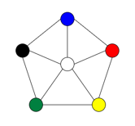
  - Apex graph: a graph where a vertex deletion makes the graph planar.

A program that 5-colors any simple, planar uncoloured graph.

Original Kempe proof (without counterexample):
Since every planar graph has a node with degree < 6 (5-degenerate), removing a node with degree < 6 forms an induced planar subgraph also possessing a node with degree < 6. So, using Kempe’s method for colouring nodes with degree < 6, we can colour all nodes recursively in the reverse order of deletion until the entire graph is coloured.
Proof by Induction:
P(n): every simple, planar graph with n vertices is 4-colorable.
Base case:
P (1) is true since a single node can be coloured with 1 colour, 1 < 4.
Inductive step:
Inductive hypothesis- Assume P(k) is true for some k.
Then add an uncoloured node to the graph to check P(k+1). If the added node has degree < 6, apply Kempe’s method and 4 colour the graph.
If the added node has a degree >= 6, remove a coloured node with <6 neighbours, by 5-degeneracy this node must exists, and by the inductive hypothesis P(k), the induced subgraph is 4 colourable. Then add the deleted node back in (as an uncoloured node) and apply Kempe’s method to 4-colour the graph.
So, P(k+1) is true.
By mathematical induction, Kempe’s method with fact of 5-degeneracy of planar graphs proves the four-colour theorem.

Our Counterexample: Kempe’s method for the 4-colour theorem fails at the following counterexample:
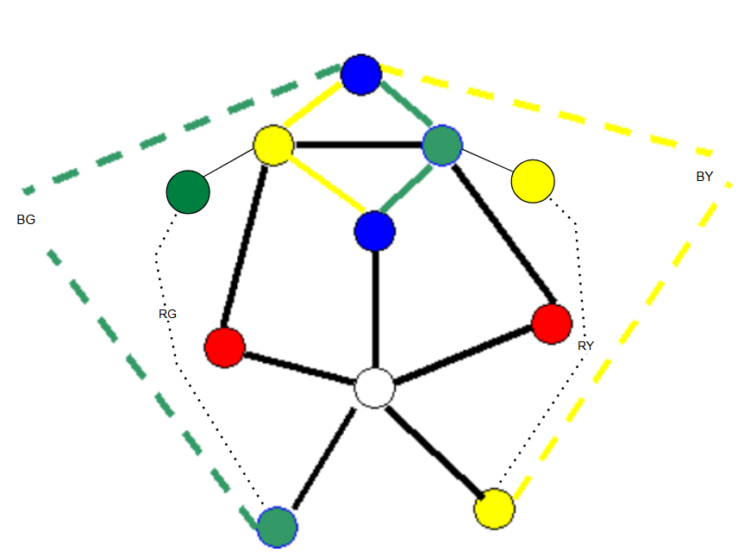

5 Colouring Program -O(n^2):
In our program, we colour the uncoloured node WHITE for the counterexample to Kempe’s method, applying a five-colour theorem.
The input to the program should be a simple, uncoloured, planar graph adjacency matrix and the number of nodes (precompile). The program will work if a K5 minor exists due to 5CT implementation but will fail for a K6 minor. The output is the colouring of the graph in nodal order.

Test Cases:
DO ANIMATION FOR EACH NODE
Applying the code to our counterexample produces the following:
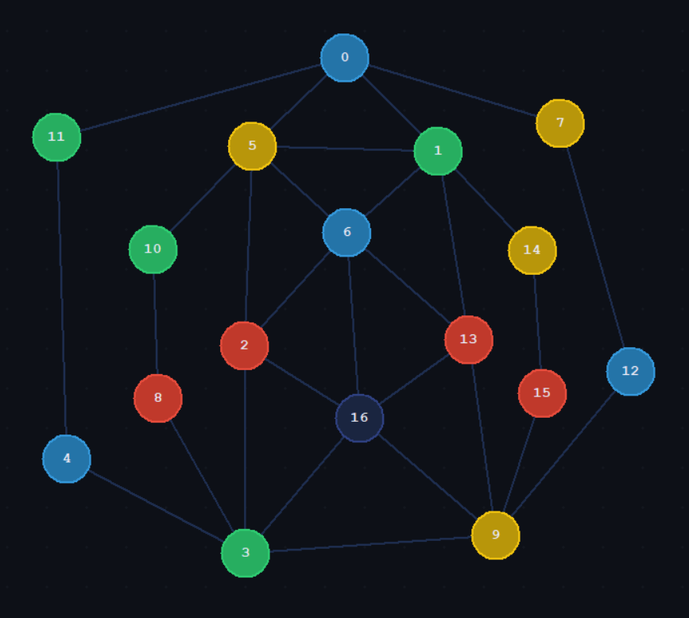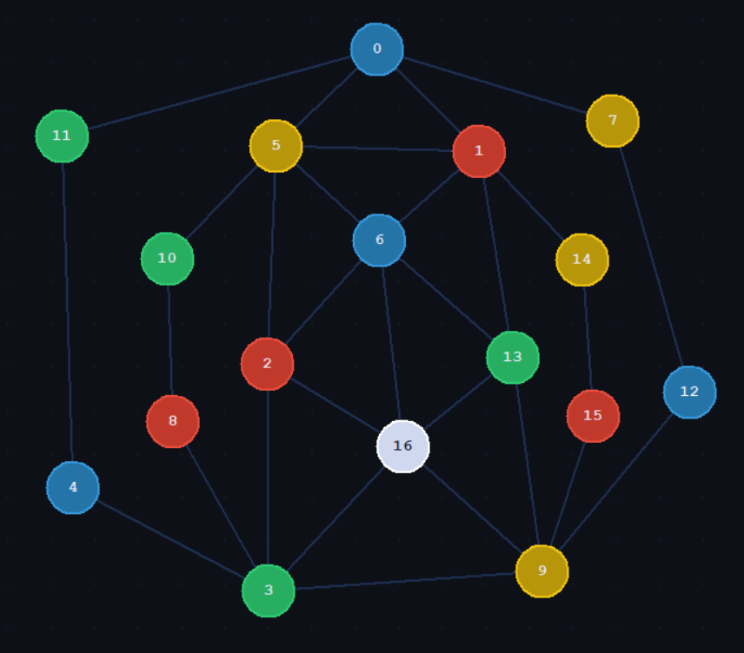
Note: Applying the program to an already coloured graph, such as our counterexample, requires a specific set up in the code to show.

K5: the program colours the graph with 5 colours: R, G, B, Y, W.

Various countries with complex provinces, states, governorates, oblasts were used. Areas were in alphabetical order; hence they can be adjacent.
India (unconnected graph):
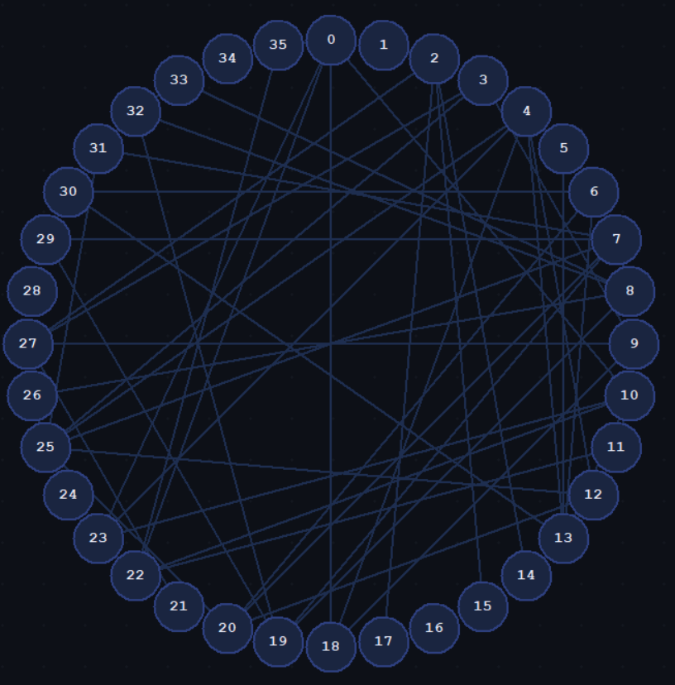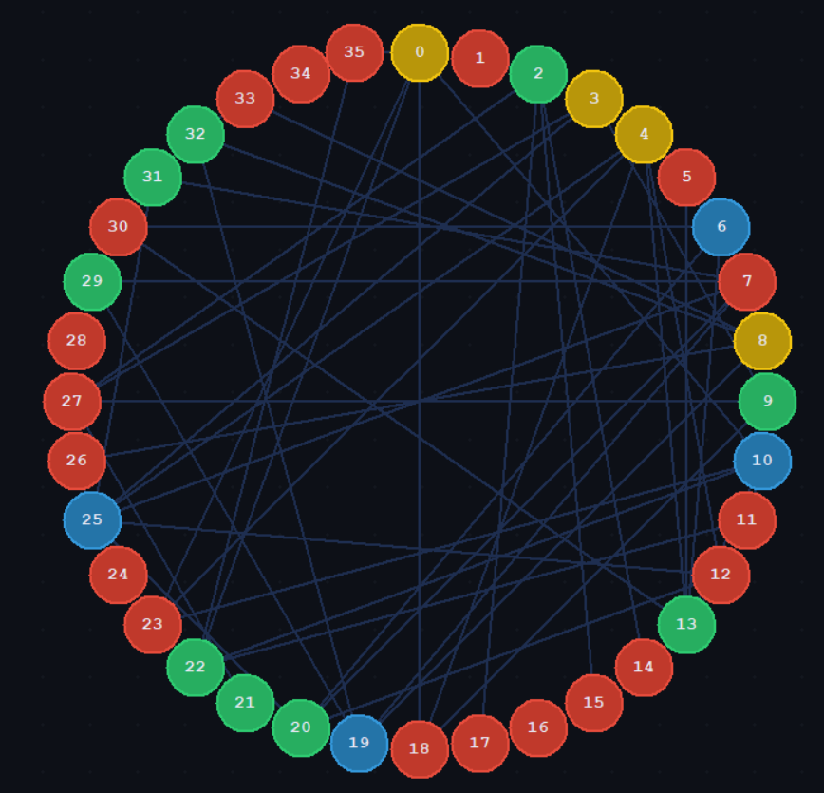
USA (connected graph, omitted alaska hawaii):
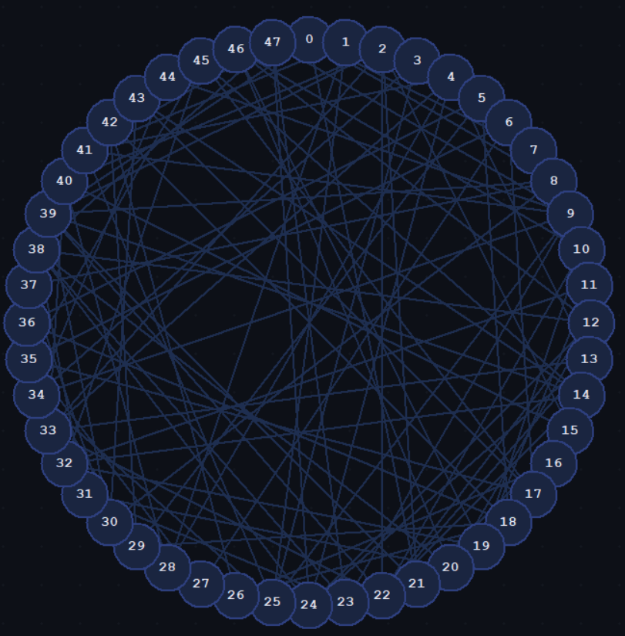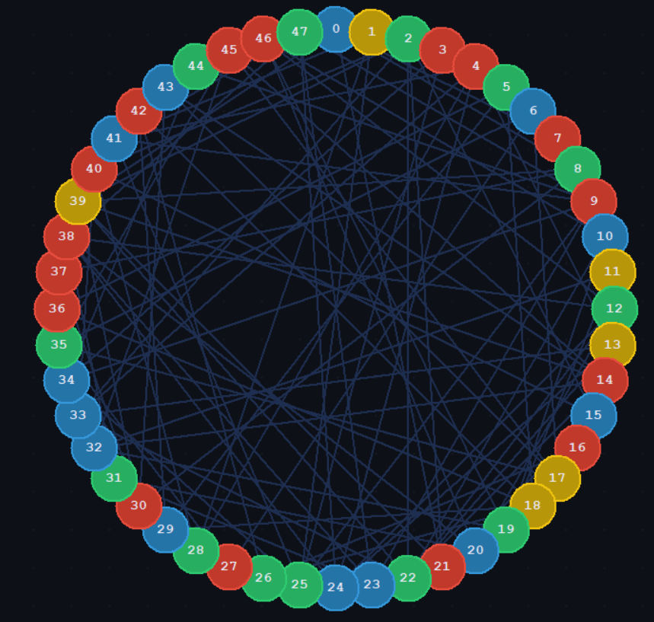

China:
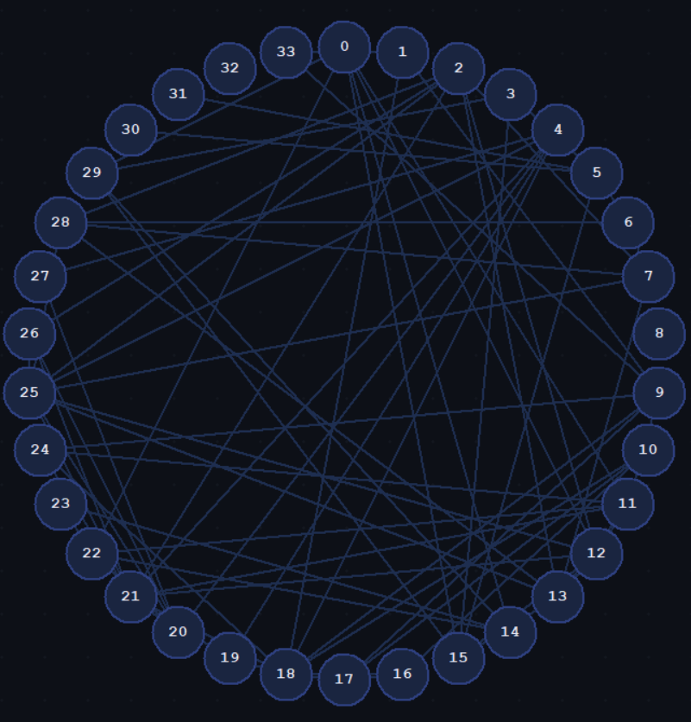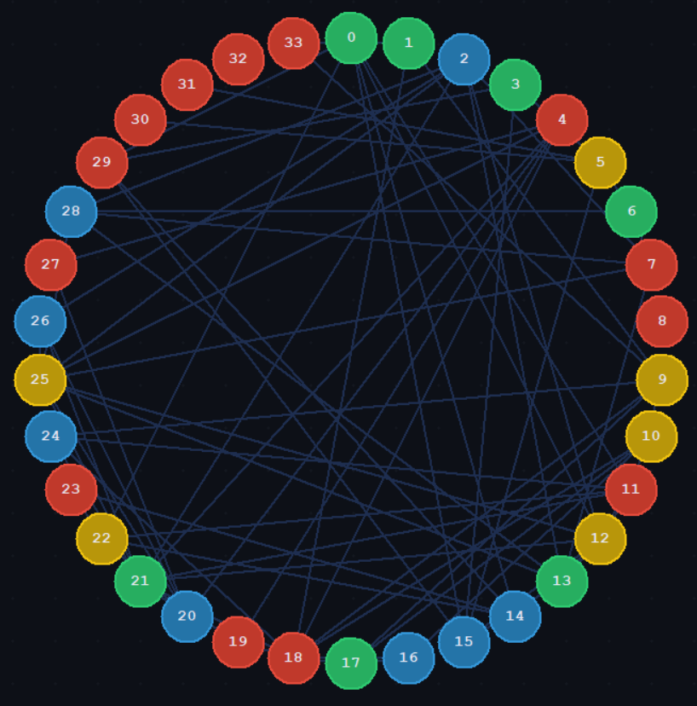
Ukraine:
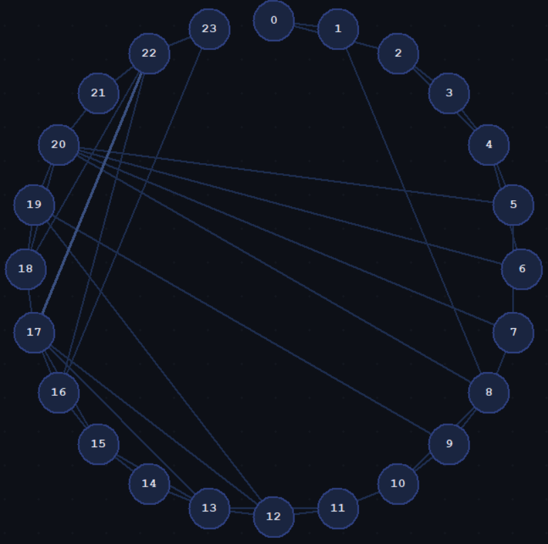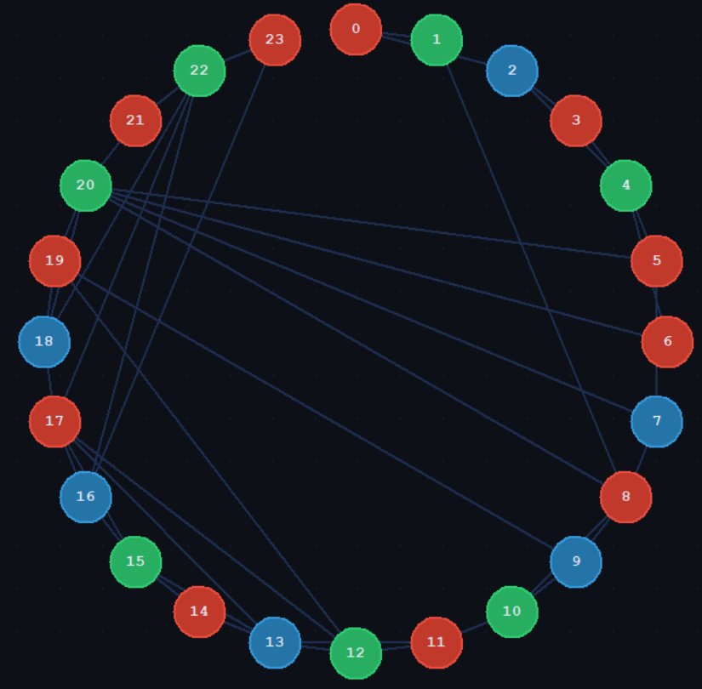
Egypt:
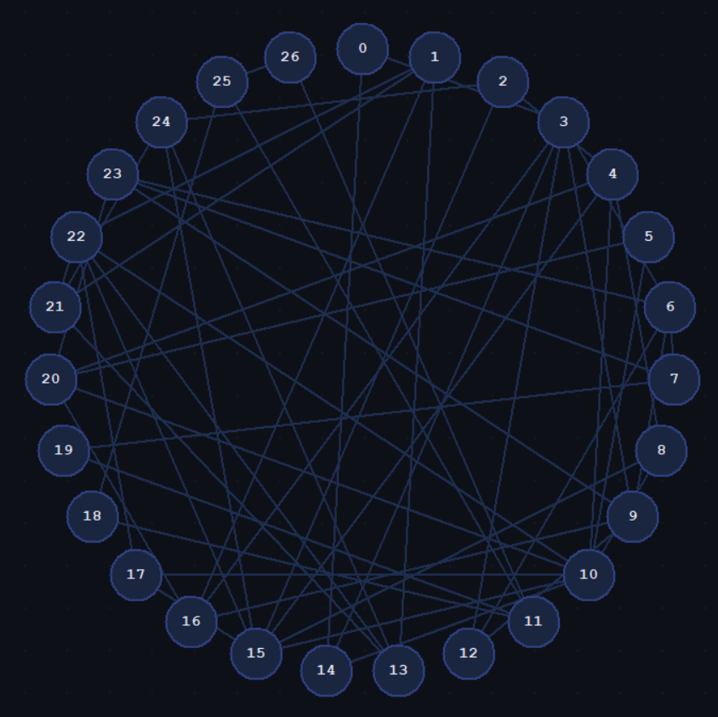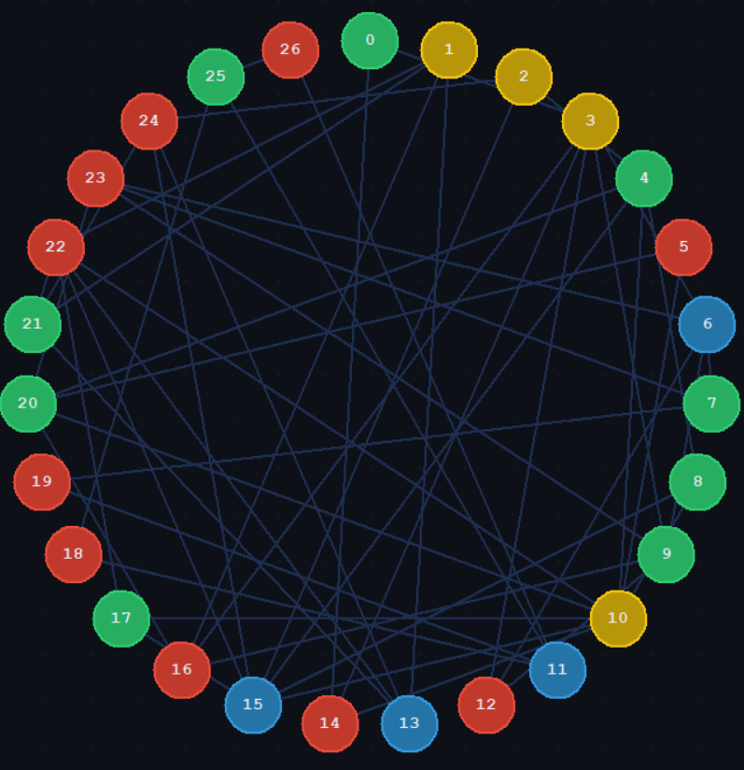
Next: Kempe 2.0
Can try test case of Kn,n,n,n,n

For map of USA- Use Graphviewer:
USA graph IMPORT:
{0, 0, 0, 0, 0, 0, 0, 1, 1, 0, 0, 0, 0, 0, 0, 0, 0, 0, 0, 0, 0, 1, 0, 0, 0, 0, 0, 0, 0, 0, 0, 0, 0, 0, 0, 0, 0, 0, 0, 1, 0, 0, 0, 0, 0, 0, 0, 0},
{0, 0, 0, 1, 0, 0, 0, 0, 0, 0, 0, 0, 0, 0, 0, 0, 0, 0, 0, 0, 0, 0, 0, 0, 0, 1, 0, 0, 1, 0, 0, 0, 0, 0, 0, 0, 0, 0, 0, 0, 0, 1, 0, 0, 0, 0, 0, 0 },
{0, 0, 0, 0, 0, 0, 0, 0, 0, 0, 0, 0, 0, 0, 0, 1, 0, 0, 0, 0, 0, 1, 1, 0, 0, 0, 0, 0, 0, 0, 0, 0, 0, 1, 0, 0, 0, 0, 0, 1, 1, 0, 0, 0, 0, 0, 0, 0 },
{0, 1, 0, 0, 0, 0, 0, 0, 0, 0, 0, 0, 0, 0, 0, 0, 0, 0, 0, 0, 0, 0, 0, 0, 0, 1, 0, 0, 0, 0, 0, 0, 0, 0, 1, 0, 0, 0, 0, 0, 0, 0, 0, 0, 0, 0, 0, 0},
{0, 0, 0, 0, 0, 0, 0, 0, 0, 0, 0, 0, 0, 1, 0, 0, 0, 0, 0, 0, 0, 0, 0, 0, 1, 0, 0, 0, 1, 0, 0, 0, 0, 1, 0, 0, 0, 0, 0, 0, 0, 1, 0, 0, 0, 0, 0, 1},
{0, 0, 0, 0, 0, 0, 0, 0, 0, 0, 0, 0, 0, 0, 0, 0, 0, 0, 1, 0, 0, 0, 0, 0, 0, 0, 0, 0, 0, 1, 0, 0, 0, 0, 0, 0, 1, 0, 0, 0, 0, 0, 0, 0, 0, 0, 0, 0},
{0, 0, 0, 0, 0, 0, 0, 0, 0, 0, 0, 0, 0, 0, 0, 0, 0, 1, 0, 0, 0, 0, 0, 0, 0, 0, 0, 1, 0, 0, 0, 0, 0, 0, 0, 1, 0, 0, 0, 0, 0, 0, 0, 0, 0, 0, 0, 0},
{1, 0, 0, 0, 0, 0, 0, 0, 1, 0, 0, 0, 0, 0, 0, 0, 0, 0, 0, 0, 0, 0, 0, 0, 0, 0, 0, 0, 0, 0, 0, 0, 0, 0, 0, 0, 0, 0, 0, 0, 0, 0, 0, 0, 0, 0, 0, 0},
{1, 0, 0, 0, 0, 0, 0, 1, 0, 0, 0, 0, 0, 0, 0, 0, 0, 0, 0, 0, 0, 0, 0, 0, 0, 0, 0, 0, 0, 0, 1, 0, 0, 0, 0, 0, 0, 1, 0, 1, 0, 0, 0, 0, 0, 0, 0, 0},
{0, 0, 0, 0, 0, 0, 0, 0, 0, 0, 0, 0, 0, 0, 0, 0, 0, 0, 0, 0, 0, 0, 0, 1, 0, 1, 0, 0, 0, 0, 0, 0, 0, 0, 1, 0, 0, 0, 0, 0, 0, 1, 0, 0, 1, 0, 0, 1},
{0, 0, 0, 0, 0, 0, 0, 0, 0, 0, 0, 1, 1, 0, 1, 0, 0, 0, 0, 1, 0, 0, 1, 0, 0, 0, 0, 0, 0, 0, 0, 0, 0, 0, 0, 0, 0, 0, 0, 0, 0, 0, 0, 0, 0, 0, 1, 0},
{0, 0, 0, 0, 0, 0, 0, 0, 0, 0, 1, 0, 0, 0, 1, 0, 0, 0, 0, 1, 0, 0, 0, 0, 0, 0, 0, 0, 0, 0, 0, 0, 1, 0, 0, 0, 0, 0, 0, 0, 0, 0, 0, 0, 0, 0, 0, 0},
{0, 0, 0, 0, 0, 0, 0, 0, 0, 0, 1, 0, 0, 0, 0, 0, 0, 0, 0, 0, 1, 0, 1, 0, 1, 0, 0, 0, 0, 0, 0, 0, 0, 0, 0, 0, 0, 0, 1, 0, 0, 0, 0, 0, 0, 0, 1, 0},
{0, 0, 0, 0, 1, 0, 0, 0, 0, 0, 0, 0, 0, 0, 0, 0, 0, 0, 0, 0, 0, 0, 1, 0, 1, 0, 0, 0, 0, 0, 0, 0, 0, 1, 0, 0, 0, 0, 0, 0, 0, 0, 0, 0, 0, 0, 0, 0},
{0, 0, 0, 0, 0, 0, 0, 0, 0, 0, 1, 1, 0, 0, 0, 0, 0, 0, 0, 0, 0, 0, 1, 0, 0, 0, 0, 0, 0, 0, 0, 0, 1, 0, 0, 0, 0, 0, 0, 1, 0, 0, 0, 1, 0, 1, 0, 0},
{0, 0, 1, 0, 0, 0, 0, 0, 0, 0, 0, 0, 0, 0, 0, 0, 0, 0, 0, 0, 0, 1, 0, 0, 0, 0, 0, 0, 0, 0, 0, 0, 0, 0, 0, 0, 0, 0, 0, 0, 1, 0, 0, 0, 0, 0, 0, 0},
{0, 0, 0, 0, 0, 0, 0, 0, 0, 0, 0, 0, 0, 0, 0, 0, 0, 0, 0, 0, 0, 0, 0, 0, 0, 0, 1, 0, 0, 0, 0, 0, 0, 0, 0, 0, 0, 0, 0, 0, 0, 0, 0, 0, 0, 0, 0, 0},
{0, 0, 0, 0, 0, 0, 0, 0, 0, 0, 0, 0, 0, 0, 0, 0, 0, 0, 0, 0, 0, 0, 0, 0, 0, 0, 0, 0, 0, 0, 0, 0, 0, 0, 0, 1, 0, 0, 0, 0, 0, 0, 0, 1, 0, 1, 0, 0},
{0, 0, 0, 0, 0, 1, 0, 0, 0, 0, 0, 0, 0, 0, 0, 0, 0, 0, 0, 0, 0, 0, 0, 0, 0, 0, 1, 0, 0, 1, 0, 0, 0, 0, 0, 0, 1, 0, 0, 0, 0, 0, 1, 0, 0, 0, 0, 0},
{0, 0, 0, 0, 0, 0, 0, 0, 0, 0, 1, 1, 0, 0, 0, 0, 0, 0, 0, 0, 0, 0, 0, 0, 0, 0, 0, 0, 0, 0, 0, 0, 1, 0, 0, 0, 0, 0, 0, 0, 0, 0, 0, 0, 0, 0, 1, 0},
{0, 0, 0, 0, 0, 0, 0, 0, 0, 0, 0, 0, 1, 0, 0, 0, 0, 0, 0, 0, 0, 0, 0, 0, 0, 0, 0, 0, 0, 0, 0, 1, 0, 0, 0, 0, 0, 0, 1, 0, 0, 0, 0, 0, 0, 0, 1, 0},
{1, 0, 1, 0, 0, 0, 0, 0, 0, 0, 0, 0, 0, 0, 0, 1, 0, 0, 0, 0, 0, 0, 0, 0, 0, 0, 0, 0, 0, 0, 0, 0, 0, 0, 0, 0, 0, 0, 0, 1, 0, 0, 0, 0, 0, 0, 0, 0},
{0, 0, 1, 0, 0, 0, 0, 0, 0, 0, 1, 0, 1, 1, 1, 0, 0, 0, 0, 0, 0, 0, 0, 0, 1, 0, 0, 0, 0, 0, 0, 0, 0, 1, 0, 0, 0, 0, 0, 1, 0, 0, 0, 0, 0, 0, 0, 0},
{0, 0, 0, 0, 0, 0, 0, 0, 0, 1, 0, 0, 0, 0, 0, 0, 0, 0, 0, 0, 0, 0, 0, 0, 0, 0, 0, 0, 0, 0, 0, 1, 0, 0, 0, 0, 0, 0, 1, 0, 0, 0, 0, 0, 0, 0, 0, 1},
{0, 0, 0, 0, 1, 0, 0, 0, 0, 0, 0, 0, 1, 1, 0, 0, 0, 0, 0, 0, 0, 0, 1, 0, 0, 0, 0, 0, 0, 0, 0, 0, 0, 0, 0, 0, 0, 0, 1, 0, 0, 0, 0, 0, 0, 0, 0, 1},
{0, 1, 0, 1, 0, 0, 0, 0, 0, 1, 0, 0, 0, 0, 0, 0, 0, 0, 0, 0, 0, 0, 0, 0, 0, 0, 0, 0, 0, 0, 0, 0, 0, 0, 1, 0, 0, 0, 0, 0, 0, 1, 0, 0, 0, 0, 0, 0},
{0, 0, 0, 0, 0, 0, 0, 0, 0, 0, 0, 0, 0, 0, 0, 0, 1, 0, 1, 0, 0, 0, 0, 0, 0, 0, 0, 0, 0, 0, 0, 0, 0, 0, 0, 0, 0, 0, 0, 0, 0, 0, 1, 0, 0, 0, 0, 0},
{0, 0, 0, 0, 0, 0, 1, 0, 0, 0, 0, 0, 0, 0, 0, 0, 0, 0, 0, 0, 0, 0, 0, 0, 0, 0, 0, 0, 0, 1, 0, 0, 0, 0, 0, 1, 0, 0, 0, 0, 0, 0, 0, 0, 0, 0, 0, 0},
{0, 1, 0, 0, 1, 0, 0, 0, 0, 0, 0, 0, 0, 0, 0, 0, 0, 0, 0, 0, 0, 0, 0, 0, 0, 0, 0, 0, 0, 0, 0, 0, 0, 1, 0, 0, 0, 0, 0, 0, 1, 0, 0, 0, 0, 0, 0, 0},
{0, 0, 0, 0, 0, 1, 0, 0, 0, 0, 0, 0, 0, 0, 0, 0, 0, 0, 1, 0, 0, 0, 0, 0, 0, 0, 0, 1, 0, 0, 0, 0, 0, 0, 0, 1, 0, 0, 0, 0, 0, 0, 1, 0, 0, 0, 0, 0},
{0, 0, 0, 0, 0, 0, 0, 0, 1, 0, 0, 0, 0, 0, 1, 0, 0, 0, 0, 0, 0, 0, 0, 0, 0, 0, 0, 0, 0, 0, 0, 0, 0, 0, 0, 0, 0, 1, 0, 1, 0, 0, 0, 1, 0, 0, 0, 0},
{0, 0, 0, 0, 0, 0, 0, 0, 0, 0, 0, 0, 0, 0, 0, 0, 0, 0, 0, 0, 1, 0, 0, 1, 0, 0, 0, 0, 0, 0, 0, 0, 0, 0, 0, 0, 0, 0, 1, 0, 0, 0, 0, 0, 0, 0, 0, 0},
{0, 0, 0, 0, 0, 0, 0, 0, 0, 0, 0, 1, 0, 0, 1, 0, 0, 0, 0, 1, 0, 0, 0, 0, 0, 0, 0, 0, 0, 0, 0, 0, 0, 0, 0, 1, 0, 0, 0, 0, 0, 0, 0, 0, 0, 1, 0, 0},
{0, 0, 1, 0, 1, 0, 0, 0, 0, 0, 0, 0, 0, 1, 0, 0, 0, 0, 0, 0, 0, 0, 1, 0, 0, 0, 0, 0, 1, 0, 0, 0, 0, 0, 0, 0, 0, 0, 0, 0, 1, 0, 0, 0, 0, 0, 0, 0},
{0, 0, 0, 1, 0, 0, 0, 0, 0, 1, 0, 0, 0, 0, 0, 0, 0, 0, 0, 0, 0, 0, 0, 0, 0, 1, 0, 0, 0, 0, 0, 0, 0, 0, 0, 0, 0, 0, 0, 0, 0, 0, 0, 0, 1, 0, 0, 0},
{0, 0, 0, 0, 0, 0, 1, 0, 0, 0, 0, 0, 0, 0, 0, 0, 0, 1, 0, 0, 0, 0, 0, 0, 0, 0, 0, 1, 0, 1, 0, 0, 1, 0, 0, 0, 0, 0, 0, 0, 0, 0, 0, 0, 0, 1, 0, 0},
{0, 0, 0, 0, 0, 1, 0, 0, 0, 0, 0, 0, 0, 0, 0, 0, 0, 0, 1, 0, 0, 0, 0, 0, 0, 0, 0, 0, 0, 1, 0, 0, 0, 0, 0, 0, 0, 0, 0, 0, 0, 0, 0, 0, 0, 0, 0, 0},
{0, 0, 0, 0, 0, 0, 0, 0, 1, 0, 0, 0, 0, 0, 0, 0, 0, 0, 0, 0, 0, 0, 0, 0, 0, 0, 0, 0, 0, 0, 1, 0, 0, 0, 0, 0, 0, 0, 0, 0, 0, 0, 0, 0, 0, 0, 0, 0},
{0, 0, 0, 0, 0, 0, 0, 0, 0, 0, 0, 0, 1, 0, 0, 0, 0, 0, 0, 0, 1, 0, 0, 1, 1, 0, 0, 0, 0, 0, 0, 1, 0, 0, 0, 0, 0, 0, 0, 0, 0, 0, 0, 0, 0, 0, 0, 1},
{1, 0, 1, 0, 0, 0, 0, 0, 1, 0, 0, 0, 0, 0, 1, 0, 0, 0, 0, 0, 0, 1, 1, 0, 0, 0, 0, 0, 0, 0, 1, 0, 0, 0, 0, 0, 0, 0, 0, 0, 0, 0, 0, 1, 0, 0, 0, 0},
{0, 0, 1, 0, 0, 0, 0, 0, 0, 0, 0, 0, 0, 0, 0, 1, 0, 0, 0, 0, 0, 0, 0, 0, 0, 0, 0, 0, 1, 0, 0, 0, 0, 1, 0, 0, 0, 0, 0, 0, 0, 0, 0, 0, 0, 0, 0, 0},
{0, 1, 0, 0, 1, 0, 0, 0, 0, 1, 0, 0, 0, 0, 0, 0, 0, 0, 0, 0, 0, 0, 0, 0, 0, 1, 0, 0, 0, 0, 0, 0, 0, 0, 0, 0, 0, 0, 0, 0, 0, 0, 0, 0, 0, 0, 0, 1},
{0, 0, 0, 0, 0, 0, 0, 0, 0, 0, 0, 0, 0, 0, 0, 0, 0, 0, 1, 0, 0, 0, 0, 0, 0, 0, 1, 0, 0, 1, 0, 0, 0, 0, 0, 0, 0, 0, 0, 0, 0, 0, 0, 0, 0, 0, 0, 0},
{0, 0, 0, 0, 0, 0, 0, 0, 0, 0, 0, 0, 0, 0, 1, 0, 0, 1, 0, 0, 0, 0, 0, 0, 0, 0, 0, 0, 0, 0, 1, 0, 0, 0, 0, 0, 0, 0, 0, 1, 0, 0, 0, 0, 0, 1, 0, 0},
{0, 0, 0, 0, 0, 0, 0, 0, 0, 1, 0, 0, 0, 0, 0, 0, 0, 0, 0, 0, 0, 0, 0, 0, 0, 0, 0, 0, 0, 0, 0, 0, 0, 0, 1, 0, 0, 0, 0, 0, 0, 0, 0, 0, 0, 0, 0, 0},
{0, 0, 0, 0, 0, 0, 0, 0, 0, 0, 0, 0, 0, 0, 1, 0, 0, 1, 0, 0, 0, 0, 0, 0, 0, 0, 0, 0, 0, 0, 0, 0, 1, 0, 0, 1, 0, 0, 0, 0, 0, 0, 0, 1, 0, 0, 0, 0},
{0, 0, 0, 0, 0, 0, 0, 0, 0, 0, 1, 0, 1, 0, 0, 0, 0, 0, 0, 1, 1, 0, 0, 0, 0, 0, 0, 0, 0, 0, 0, 0, 0, 0, 0, 0, 0, 0, 0, 0, 0, 0, 0, 0, 0, 0, 0, 0},
{0, 0, 0, 0, 1, 0, 0, 0, 0, 1, 0, 0, 0, 0, 0, 0, 0, 0, 0, 0, 0, 0, 0, 1, 1, 0, 0, 0, 0, 0, 0, 0, 0, 0, 0, 0, 0, 0, 1, 0, 0, 1, 0, 0, 0, 0, 0, 0}

Colours: 2 4 2 1 1 2 3 1 3 1 3 4 2 4 1 3 1 4 4 2 3 1 2 3 3 2 2 1 2 3 2 2 3 3 3 2 1 1 1 4 1 3 1 3 2 1 1 2

Error in node 2 and 22.

Egypt:

int egypt_adj[27][27] = {

{0,0,0,1,0,0,0,0,0,0,0,0,0,0,1,0,0,0,0,0,0,0,0,0,0,0,0}, // Alexandria
{0,0,0,0,0,0,0,0,0,0,0,0,0,1,0,0,1,0,0,0,0,1,1,0,0,0,0}, // Aswan
{0,0,0,0,1,0,0,0,0,0,0,0,0,0,0,1,0,0,0,0,0,0,0,0,1,0,0}, // Asyut
{1,0,0,0,0,0,1,0,0,1,0,0,1,0,1,0,1,0,0,0,0,0,0,0,0,0,0}, // Beheira
{0,0,1,0,0,0,0,0,1,0,1,0,0,0,0,1,0,0,0,0,1,0,0,0,0,0,0}, // Beni Suef
{0,0,0,0,0,0,0,0,0,0,1,0,0,0,0,0,0,0,0,0,1,0,0,0,0,0,0}, // Cairo
{0,0,0,1,0,0,0,1,0,1,0,0,1,0,0,0,0,0,0,0,0,0,0,1,0,0,0}, // Dakahlia
{0,0,0,0,0,0,1,0,0,0,0,0,0,0,0,0,0,0,0,1,0,0,0,1,0,0,0}, // Damietta
{0,0,0,0,1,0,0,0,0,0,1,0,0,0,0,1,0,0,0,0,0,0,0,0,0,0,0}, // Faiyum
{0,0,0,1,0,0,1,0,0,0,0,0,1,0,0,0,1,0,0,0,0,0,0,1,0,0,0}, // Gharbia
{0,0,0,0,1,1,0,0,1,0,0,0,0,0,1,1,0,1,0,0,1,0,1,0,0,0,0}, // Giza
{0,0,0,0,0,0,0,0,0,0,0,0,0,0,0,0,0,0,1,1,0,0,0,0,0,1,1}, // Ismailia
{0,0,0,1,0,0,1,0,0,1,0,0,0,0,0,0,0,0,0,0,0,0,0,0,0,0,0}, // Kafr El Sheikh
{0,1,0,0,0,0,0,0,0,0,0,0,0,0,0,0,0,0,0,0,0,1,1,0,1,0,0}, // Luxor
{1,0,0,1,0,0,0,0,0,0,1,0,0,0,0,0,0,0,0,0,0,0,0,0,0,0,0}, // Matrouh
{0,0,1,0,1,0,0,0,1,0,1,0,0,0,0,0,0,1,0,0,0,0,1,0,1,0,0}, // Minya
{0,0,0,1,0,0,0,0,0,1,0,0,0,0,0,0,0,0,0,0,1,0,0,0,0,0,0}, // Monufia
{0,1,0,0,0,0,0,0,0,0,1,0,0,0,0,1,0,0,0,0,0,0,1,0,0,0,0}, // New Valley
{0,0,0,0,0,0,0,0,0,0,0,1,0,0,0,0,0,0,0,0,0,0,0,0,0,1,0}, // North Sinai
{0,0,0,0,0,0,0,1,0,0,0,1,0,0,0,0,0,0,0,0,0,0,0,0,0,0,0}, // Port Said
{0,0,0,0,1,1,0,0,0,0,1,0,0,0,0,0,1,0,0,0,0,0,0,1,0,0,0}, // Qalyubia
{0,1,0,0,0,0,0,0,0,0,0,0,0,1,0,0,0,0,0,0,0,0,1,0,1,0,0}, // Qena
{0,1,0,0,0,0,0,0,0,0,1,0,0,1,0,1,0,1,0,0,0,1,0,0,0,0,0}, // Red Sea
{0,0,0,0,0,0,1,1,0,1,0,0,0,0,0,0,0,0,0,0,1,0,0,0,0,0,0}, // Sharqia
{0,0,1,0,0,0,0,0,0,0,0,0,0,1,0,1,0,0,0,0,0,1,0,0,0,0,0}, // Sohag
{0,0,0,0,0,0,0,0,0,0,0,1,0,0,0,0,0,0,1,0,0,0,0,0,0,0,1}, // South Sinai
{0,0,0,0,0,0,0,0,0,0,0,1,0,0,0,0,0,0,0,0,0,0,0,0,0,1,0} // Suez

};

int ukraine_adj[24][24] = {
{0,1,1,0,0,0,0,0,0,0,0,0,0,0,0,0,0,0,0,0,0,0,0,0}, // Volyn
{1,0,0,0,0,0,0,0,1,0,0,0,0,0,0,0,0,0,0,0,0,0,0,0}, // Rivne
{1,0,0,1,1,0,0,0,0,0,0,0,0,0,0,0,0,0,0,0,0,0,0,0}, // Lviv
{0,0,1,0,1,0,0,0,0,0,0,0,0,0,0,0,0,0,0,0,0,0,0,0}, // Zakarpattia
{0,0,1,1,0,1,1,0,0,0,0,0,0,0,0,0,0,0,0,0,0,0,0,0}, // Ivano-Frankivsk
{0,0,0,0,1,0,0,1,0,0,0,0,0,0,0,0,0,0,0,0,1,0,0,0}, // Ternopil
{0,0,0,0,1,0,0,0,0,0,0,0,0,0,0,0,0,0,0,0,1,0,0,0}, // Chernivtsi
{0,0,0,0,0,1,0,0,1,0,0,0,0,0,0,0,0,0,0,0,1,0,0,0}, // Khmelnytskyi
{0,1,0,0,0,0,0,1,0,1,1,0,0,0,0,0,0,0,0,0,1,0,0,0}, // Zhytomyr
{0,0,0,0,0,0,0,0,1,0,1,0,0,0,0,0,0,0,0,1,0,0,0,0}, // Kyiv
{0,0,0,0,0,0,0,0,1,1,0,1,0,0,0,0,0,0,0,0,0,0,0,0}, // Chernihiv
{0,0,0,0,0,0,0,0,0,0,1,0,1,1,0,0,0,0,0,0,0,0,0,0}, // Sumy
{0,0,0,0,0,0,0,0,0,0,0,1,0,1,0,0,0,1,0,1,0,0,0,0}, // Poltava
{0,0,0,0,0,0,0,0,0,0,0,1,1,0,1,1,0,1,0,0,0,0,0,0}, // Kharkiv
{0,0,0,0,0,0,0,0,0,0,0,0,0,1,0,1,0,0,0,0,0,0,0,0}, // Luhansk
{0,0,0,0,0,0,0,0,0,0,0,0,0,1,1,0,1,1,0,0,0,0,0,0}, // Donetsk
{0,0,0,0,0,0,0,0,0,0,0,0,0,0,0,1,0,1,0,0,0,0,1,1}, // Zaporizhzhia
{0,0,0,0,0,0,0,0,0,0,0,0,1,1,0,1,1,0,1,0,0,0,1,0}, // Dnipropetrovsk
{0,0,0,0,0,0,0,0,0,0,0,0,0,0,0,0,0,1,0,1,1,0,1,0}, // Kirovohrad
{0,0,0,0,0,0,0,0,0,1,0,0,1,0,0,0,0,0,1,0,1,0,0,0}, // Cherkasy
{0,0,0,0,0,1,1,1,1,0,0,0,0,0,0,0,0,0,1,1,0,1,0,0}, // Vinnytsia
{0,0,0,0,0,0,0,0,0,0,0,0,0,0,0,0,0,0,0,0,1,0,1,0}, // Odesa
{0,0,0,0,0,0,0,0,0,0,0,0,0,0,0,0,1,1,1,0,0,1,0,1}, // Mykolaiv
{0,0,0,0,0,0,0,0,0,0,0,0,0,0,0,0,1,0,0,0,0,0,1,0} // Kherson
};

int china_adj[34][34] = {
{0,0,0,0,0,0,0,0,0,0,0,1,1,0,1,1,0,0,0,0,0,0,1,0,0,0,0,0,0,1,0,0,0,0}, // Anhui
{0,0,0,0,0,0,0,0,0,1,0,0,0,0,0,0,0,0,1,0,0,0,0,0,0,0,0,0,0,0,0,0,0,1}, // Beijing
{0,0,0,0,0,0,0,1,0,0,0,0,1,1,0,0,0,0,0,0,0,1,0,0,0,1,1,0,1,0,0,0,0,0}, // Chongqing
{0,0,0,0,0,1,0,0,0,0,0,0,0,0,0,1,0,0,0,0,0,0,0,0,0,0,0,0,0,1,0,0,0,0}, // Fujian
{0,0,0,0,0,0,0,0,0,0,0,0,0,0,0,0,0,0,1,1,1,1,0,0,0,1,0,1,0,0,0,0,0,0}, // Gansu
{0,0,0,1,0,0,1,0,0,0,0,0,0,0,0,1,0,0,0,0,0,0,0,0,0,0,0,0,0,0,1,1,0,0}, // Guangdong
{0,0,0,0,0,1,0,1,0,0,0,0,0,0,0,0,0,0,0,0,0,0,0,0,0,0,0,0,1,0,0,0,0,0}, // Guangxi
{0,0,1,0,0,0,1,0,0,0,0,0,0,1,0,0,0,0,0,0,0,0,0,0,0,1,0,0,1,0,0,0,0,0}, // Guizhou
{0,0,0,0,0,0,0,0,0,0,0,0,0,0,0,0,0,0,0,0,0,0,0,0,0,0,0,0,0,0,0,0,0,0}, // Hainan
{0,1,0,0,0,0,0,0,0,0,0,1,0,0,0,0,0,1,1,0,0,0,0,0,1,0,0,0,0,0,0,0,0,1}, // Hebei
{0,0,0,0,0,0,0,0,0,0,0,0,0,0,0,0,1,1,1,0,0,0,0,0,0,0,0,0,0,0,0,0,0,0}, // Heilongjiang
{1,0,0,0,0,0,0,0,0,1,0,0,1,1,0,0,0,0,0,0,0,1,1,0,1,0,0,0,0,0,0,0,0,0}, // Henan
{1,0,1,0,0,0,0,0,0,0,0,1,0,1,0,1,0,0,0,0,0,1,0,0,0,1,0,0,0,0,0,0,0,0}, // Hubei
{0,0,1,0,0,0,0,1,0,0,0,1,1,0,0,1,0,0,0,0,0,0,0,0,0,1,0,0,1,0,0,0,0,0}, // Hunan
{1,0,0,0,0,0,0,0,0,0,0,0,0,0,0,0,0,0,0,0,0,0,1,1,0,0,0,0,0,1,0,0,0,0}, // Jiangsu
{1,0,0,1,0,1,0,0,0,0,0,0,1,1,0,0,0,0,0,0,0,0,0,0,0,0,0,0,0,1,0,0,0,0}, // Jiangxi
{0,0,0,0,0,0,0,0,0,0,1,0,0,0,0,0,0,1,1,0,0,0,0,0,0,0,0,0,0,0,0,0,0,0}, // Jilin
{0,0,0,0,0,0,0,0,0,1,1,0,0,0,0,0,1,0,1,0,0,0,0,0,0,0,0,0,0,0,0,0,0,0}, // Liaoning
{0,1,0,0,1,0,0,0,0,1,1,0,0,0,0,0,1,1,0,1,0,1,0,0,1,0,0,0,0,0,0,0,0,0}, // Inner Mongolia
{0,0,0,0,1,0,0,0,0,0,0,0,0,0,0,0,0,0,1,0,0,1,0,0,0,0,0,0,0,0,0,0,0,0}, // Ningxia
{0,0,0,0,1,0,0,0,0,0,0,0,0,0,0,0,0,0,0,0,0,1,1,0,0,1,1,1,0,0,0,0,0,0}, // Qinghai
{0,0,1,0,1,0,0,0,0,0,0,1,1,0,0,0,0,0,1,1,1,0,0,0,1,1,1,0,0,0,0,0,0,0}, // Shaanxi
{1,0,0,0,0,0,0,0,0,0,0,1,0,0,1,0,0,0,0,0,1,0,0,1,0,0,0,0,0,0,0,0,0,0}, // Shandong
{0,0,0,0,0,0,0,0,0,0,0,0,0,0,1,0,0,0,0,0,0,0,1,0,0,0,0,0,0,0,0,0,0,0}, // Shanghai
{0,0,0,0,0,0,0,0,0,1,0,1,0,0,0,0,0,0,1,0,0,1,0,0,0,0,0,0,0,0,0,0,0,0}, // Shanxi
{0,0,1,0,1,0,0,1,0,0,0,0,1,1,0,0,0,0,0,0,1,1,0,0,0,0,1,0,1,0,0,0,0,0}, // Sichuan
{0,0,1,0,0,0,0,0,0,0,0,0,0,0,0,0,0,0,0,0,1,1,0,0,0,1,0,0,0,0,0,0,0,0}, // Tibet
{0,0,0,0,1,0,0,0,0,0,0,0,0,0,0,0,0,0,0,0,1,0,0,0,0,0,0,0,0,0,0,0,0,0}, // Xinjiang
{0,0,1,0,0,0,1,1,0,0,0,0,0,1,0,0,0,0,0,0,0,0,0,0,0,1,0,0,0,0,0,0,0,0}, // Yunnan
{1,0,0,1,0,0,0,0,0,0,0,0,0,0,1,1,0,0,0,0,0,0,0,0,0,0,0,0,0,0,0,0,0,0}, // Zhejiang
{0,0,0,0,0,1,0,0,0,0,0,0,0,0,0,0,0,0,0,0,0,0,0,0,0,0,0,0,0,0,0,0,0,0}, // Hong Kong
{0,0,0,0,0,1,0,0,0,0,0,0,0,0,0,0,0,0,0,0,0,0,0,0,0,0,0,0,0,0,0,0,0,0}, // Macau
{0,0,0,0,0,0,0,0,0,0,0,0,0,0,0,0,0,0,0,0,0,0,0,0,0,0,0,0,0,0,0,0,0,0}, // Taiwan
{0,1,0,0,0,0,0,0,0,1,0,0,0,0,0,0,0,0,0,0,0,0,0,0,0,0,0,0,0,0,0,0,0,0} // Tianjin
};

int iran[31][31] = {
{0,0,0,0,0,0,0,0,0,0,0,0,0,0,0,0,0,0,0,0,0,0,0,0,1,0,0,0,1,0,1},
{0,0,1,0,0,0,0,1,0,0,0,0,0,0,0,0,0,0,0,0,0,0,0,0,0,0,0,0,0,0,1},
{0,1,0,1,0,0,0,0,0,0,0,0,0,0,0,0,0,0,0,0,0,0,0,0,0,0,0,0,0,0,1},
{0,0,1,0,0,0,0,0,0,0,0,0,0,0,1,0,0,0,0,0,1,0,0,0,0,0,0,0,0,0,0},
{0,0,0,0,0,0,1,0,0,0,1,0,0,0,0,0,0,0,1,0,0,0,0,0,0,0,0,0,0,0,0},
{0,0,0,0,0,0,0,0,0,0,0,0,1,0,0,0,0,0,0,1,0,1,0,0,0,0,0,0,0,0,0},
{0,0,0,0,1,0,0,0,0,0,1,0,1,0,0,0,0,0,0,1,0,0,0,0,0,0,0,0,0,0,0},
{0,1,0,0,0,0,0,0,1,0,0,0,0,0,0,0,0,0,0,0,0,0,0,1,0,0,0,0,0,0,0},
{0,0,0,0,0,0,0,1,0,0,0,0,0,0,0,1,1,0,0,0,0,0,0,1,0,0,1,0,0,0,0},
{0,0,0,0,0,0,0,0,0,0,0,0,0,0,1,0,0,0,0,0,1,1,0,0,0,0,0,0,0,0,0},
{0,0,0,0,1,0,1,0,0,0,0,0,0,1,0,0,0,0,0,0,0,0,0,0,0,0,0,0,0,0,0},
{0,0,0,0,0,0,0,0,0,0,0,0,0,0,1,0,0,0,1,0,0,1,0,0,0,0,0,0,0,0,0},
{0,0,0,0,0,1,1,0,0,0,0,0,0,0,0,0,0,0,0,0,0,0,1,0,0,1,1,0,0,1,0},
{0,0,0,0,0,0,0,0,0,0,1,0,0,0,0,0,1,1,0,0,0,0,0,0,0,0,0,1,0,1,0},
{0,0,0,1,0,0,0,0,0,1,0,1,0,0,0,0,0,0,0,0,1,1,0,0,0,0,0,0,0,0,0},
{0,0,0,0,0,0,0,0,1,0,0,0,0,0,0,0,1,0,0,0,0,0,0,0,0,0,1,0,0,0,0},
{0,0,0,0,0,0,0,0,1,0,0,0,0,1,0,1,0,1,0,0,0,0,0,0,0,0,1,0,0,0,0},
{0,0,0,0,0,0,0,0,0,0,0,0,0,1,0,0,1,0,0,0,0,0,0,0,0,0,0,1,0,1,0},
{0,0,0,0,1,0,0,0,0,0,0,1,0,0,0,0,0,0,0,0,0,1,0,0,0,0,0,0,0,0,0},
{0,0,0,0,0,1,1,0,0,0,0,0,0,0,0,0,0,0,0,0,0,0,0,0,0,0,0,0,0,0,0},
{0,0,0,1,0,0,0,0,0,1,0,0,0,0,1,0,0,0,0,0,0,0,0,0,0,0,0,0,0,0,1},
{0,0,0,0,0,1,0,0,0,1,0,1,0,0,1,0,0,0,1,0,0,0,0,0,0,0,0,0,0,0,0},
{0,0,0,0,0,0,0,0,0,0,0,0,1,0,0,0,0,0,0,0,0,0,0,0,1,1,0,0,1,0,1},
{0,0,0,0,0,0,0,1,1,0,0,0,0,0,0,0,0,0,0,0,0,0,0,0,1,0,1,0,0,0,0},
{1,0,0,0,0,0,0,0,0,0,0,0,0,0,0,0,0,0,0,0,0,0,1,1,0,0,0,0,1,0,1},
{0,0,0,0,0,0,0,0,0,0,0,0,1,0,0,0,0,0,0,0,0,0,1,0,0,0,1,0,1,0,0},
{0,0,0,0,0,0,0,0,1,0,0,0,1,0,0,1,1,0,0,0,0,0,0,1,0,1,0,0,0,1,0},
{0,0,0,0,0,0,0,0,0,0,0,0,0,1,0,0,0,1,0,0,0,0,0,0,0,0,0,0,0,1,0},
{1,0,0,0,0,0,0,0,0,0,0,0,0,0,0,0,0,0,0,0,0,0,1,0,1,1,0,0,0,0,0},
{0,0,0,0,0,0,0,0,0,0,0,0,1,1,0,0,0,1,0,0,0,0,0,0,0,0,1,1,0,0,0},
{1,1,1,0,0,0,0,0,0,0,0,0,0,0,0,0,0,0,0,0,1,0,1,0,1,0,0,0,0,0,0}
};

